Project Title: Emerging methods for early detection of forest fires Project Design Phase-I - Solution Fit Template Team ID: PNT2022TMID40862

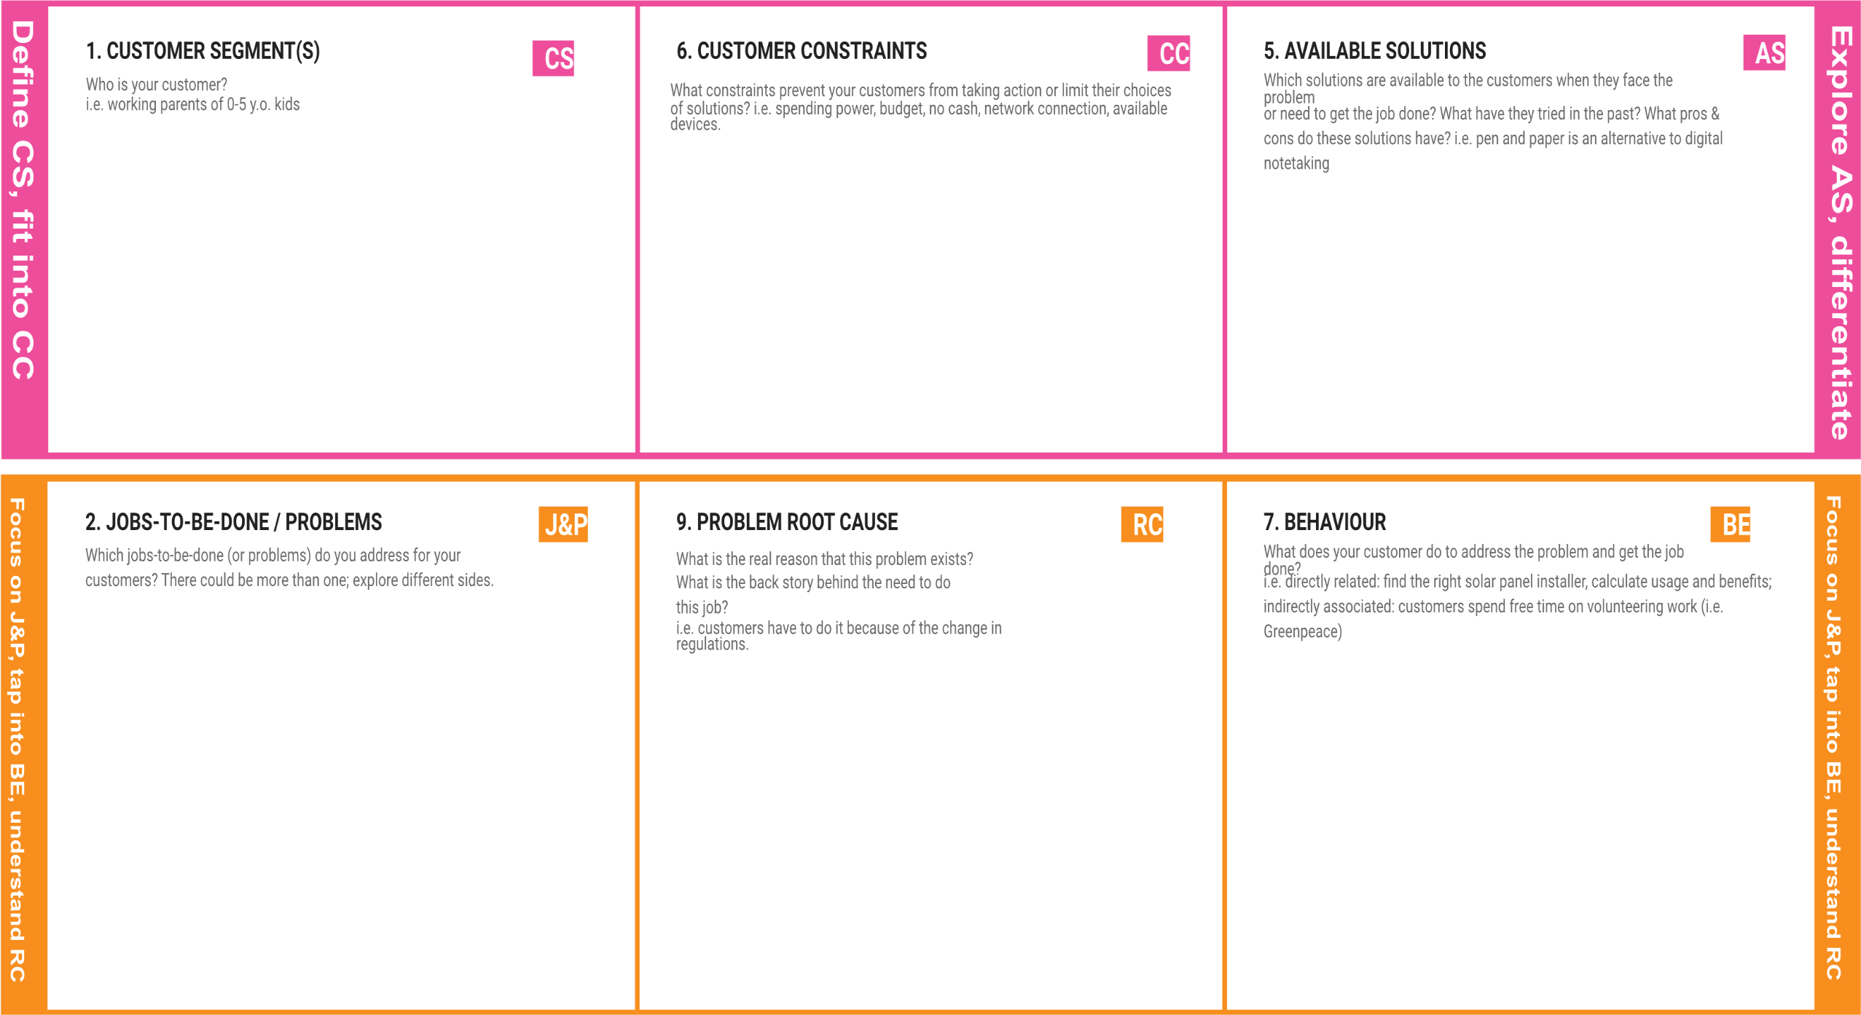

Forest Department officials who will be immediately informed in case of forest fire detection.

Also educated tribals/forest living people may be our customers who can be alerted in right time.

The main constraint is that fires are detected very late and it becomes difficult to suppress and track the exact origin of fire.

It requires lot of water, gas and human resources to suppress huge fires. Also money spent is huge.

For forest living people, they fear to leave their cattles, properties alone in fear of fires.

**In the past, forest fires were detected using watchtowers, which were not efficient because they were based on human observations.**

**In recent history and even the present day, satellite image processing methods, wireless sensor network, optical sensors, CO2 and gas sensor-based methods exist.**

**But there are some drawbacks, such as inefficiency, power consumption, latency, accuracy and implementation costs for above methods.**

* The main problem is forest fires are detected very late before which more damage is caused to our most valuable ecological resources.
* We propose a method for early detection of forest fires and intimation of authorities immediately.
* We also predict the probability of occurrence of forest fires in a particular area at a particular season.

These fires can be caused by natural reasons, such as high temperatures that can create spontaneous combustion of dry fuel such as sawdust, leaves, lightning, etc.,

They are also caused by human activities, such as unextinguished campfires, arson, inappropriately burned debris, etc.

Forest authorities need to extinguish fire as soon as possible to save lives, habitat and even our environment.

The customer needs to search for proper solution available in net or through various sources and find feasible methods.

They need to critically analyze the suitability and benefits of the solutions available and choose the most suited one for their requirements and particular scenario.

Also customers can spend free time to address various other problems in forest than these fires.

|  |  |  |  |  |
| --- | --- | --- | --- | --- |
|  | **3. TRIGGERS TR**  What triggers customers to act? i.e. seeing their neighbour installing solar panels, reading about a more efficient solution in the news.  **Forest Department officials have pressure from government and Environmentalists to preserve the most essential forest cover and wildlife.**  **Also they have responsibility of reducing the green house effects, CO2 emissions and climatic change. So preventing effects of forest fires is extremely important task for them**  **Also customers act by seeing the effectiveness of our solution and knowing about them in our websites.** | **10. YOUR SOLUTION SL**  If you are working on an existing business, write down your current solution first, fill in the canvas, and check how much it fits reality.  If you are working on a new business proposition, then keep it blank until you fill in the canvas and come up with a solution that fits within customer limitations, solves a problem and matches customer behaviour.  **The user interacts with a web camera to read the video.**  **Once the input image from the video frame is sent to the model, if the fire is detected, it is showcased on the console, and alerting sound will be generated and an alert message will be sent to the Authorities.**  **To achieve this, we classify images using a Convolutional Neural Network and use other open CV tools.**  **In reality, this solution requires HD cameras to be installed in forests or needs data from satellites. This increases cost of installation but satisfies the**  **customer requirements and addresses their**  **problem** | 1. **CHANNELS of BEHAVIOUR CH**    1. **ONLINE**   What kind of actions do customers take online? Extract online channels from #7   * 1. **OFFLINE**   What kind of actions do customers take offline? Extract offline channels from #7 and use them for customer development.  **In online, customers can inspect the status of various places in forest and also get an idea of what is going on in the forest.**  **Also customers will have ready data to know the probability of occurrence of fires in an area so that they can make arrangements ready in case of emergency.**  **In, offline they can directly go to the affected area and immediately suppress the fire and save huge amount cost, time, resources and efforts.**  **In the remaining time, forest officials can concentrate on other important aspects of enriching our flora and fauna and maintaining ecological balance.** |  |
| **4. EMOTIONS: BEFORE / AFTER EM**  How do customers feel when they face a problem or a job and afterwards?  i.e. lost, insecure > confident, in control - use it in your communication strategy & design.   * + **Forest Department officials feel helpless when huge portion of forest cover is affected by fires. They find it very difficult to control them.**   + **The lives of tribal people and their properties are also insecure as any time fires can damage their valuables.**   + **After we implement our solution, they can be relieved and confident that natural resources is safe and they can immediately take right action at right time.** |